**Cells shaded in blue denote software components sourced from the VA satellite repository or Infrastructure Operations “gold image” Linux build for which the TAS team does not control versions.**

| **Resource** | **Description** | **Version** |
| --- | --- | --- |
| Red Hat Enterprise Linux | Red Hat Enterprise Linux (RHEL). | 7.3 |
| International Business Machine (IBM) BigFix | IBM BigFix Agent for Linux (BES Agent). | 9.5.9.62-rhe6.x86_64 |
| EnCase Agent | Servlet needed for forensic examination of a Linux server by Encase. | 7.10.4.2-3.el7.x86_64 |
| McAfee Agent | CA McAfee Security Agent. | 5.0.5-658.x86_64 |
| Centrify Infrastructure Services | Centrify DirectControl (DC) Agent. | 2018 5.5.2-578 |
| Rational Team Concert (RTC) Eclipse Client | Plugin that provides system-level access to the RTC server, giving users direct access to the RTC server rather than via the web interface. | 6.0.6 |
| Jenkins | Continuous Integration and Deployment Software to automate installation, build, and deployment of software. | 2.150.2 |
| Ansible | Deployment and orchestration tool. | 2.4.2.0 |
| Computer Associates (CA) Single Sign-On (SSO) | Policy-based authentication as well as single sign-on for Web-based applications (SiteMinder). | 12.51 cr08 |
| Node Package Manager (NPM) | Package Manager for JavaScript. | 5.x |
| Font Awesome | Enables customization of scalable vector icons used in CSS. | 4.7.x |
| Apache Hypertext Transfer Protocol (HTTP) Server | Provides a secure, efficient and extensible server that provides HTTP services in sync with the current HTTP standards. | 2.4.6-45 |
| Apache Tomcat | Open source software providing Java Servlet and Java Server Pages functionalities. It can be used alone as a Java based web server or with formal web server products (e.g., Apache HTTP Server) to provide dynamic content. | 9.0.5 |
| U.S. Web Design Standards Framework | Open source UI components and visual style guide for U.S. government websites. | 1.1.0 |
| Node.js | A JavaScript runtime built on Chrome’s VS Java Script engine. | 8.x |
| Process Manager 2 (PM2) | Advanced production process manager for Node.js. | 2.4 |
| PrimeNG | A component library for Angular 2/4 that provides critical business UI functionality such as various data grids, pick lists, org charts, and autocomplete boxes. | 4.2 |
| Angular | Open source development platform and framework used for building mobile and desktop web applications using TypeScript/JavaScript and other languages. | 4.0 |
| RabbitMQ | Open source message broker that allows applications to connect and scale through a common platform for sending, receiving and temporarily storing inter-application messages between distributed systems. It is developed to implement AMQP (Advanced Message Queuing Protocol) to work across different platforms and languages. | 3.7.7 |
| Health Level 7 (HL7) Application Programming Interface (API) (HAPI) – Fast Healthcare Interoperable Resources (FHIR) | Open source HAPI library implementation of the FHIR specification in Java. HAPI allows users to add HL7 capability to applications, as well as leveraging FHIR specifications for exchanging healthcare data. | 2.5 |
| Docker - Community Edition (CE) | Open source software container platform to build, ship and run distributed applications. Docker enables developers to package all libraries and settings required for software to operate without having to bundle in a complete operating system, which allows software to scale regardless of development platform.  It provides ability to cluster a group of Docker hosts into a single virtual server called a swarm. | 17.09.1 |
| Nginx | Open source hypertext transfer protocol (HTTP) server, reverse proxy and internet message access protocol (IMAP) / post office protocol (POP3) server. Designed to be a powerful, scalable and predictable alternative to modern servers, it consumes fewer network resources. | 1.14.1 |
| Fortify Static Code Analyzer | Code analysis tool that processes code similar to a compiler and optimizes it to analyze then it for violations of secure coding practices. | 2019.1.0 |

**Red Hat Linux 7.3** [**http://trm.oit.va.gov/ToolPage.aspx?tid=6367&tab=2**](http://trm.oit.va.gov/ToolPage.aspx?tid=6367&tab=2)

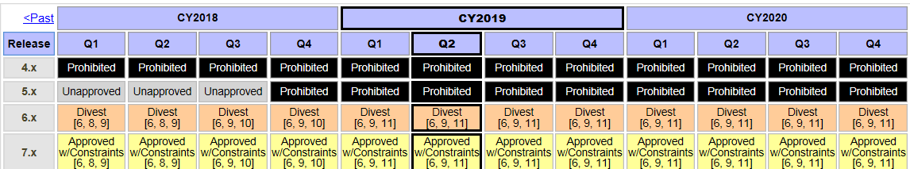

**International Business Machine (IBM) BigFix 9.5.9.62-rhe6.x86_64** [**http://trm.oit.va.gov/ToolPage.aspx?tid=6492#**](http://trm.oit.va.gov/ToolPage.aspx?tid=6492)

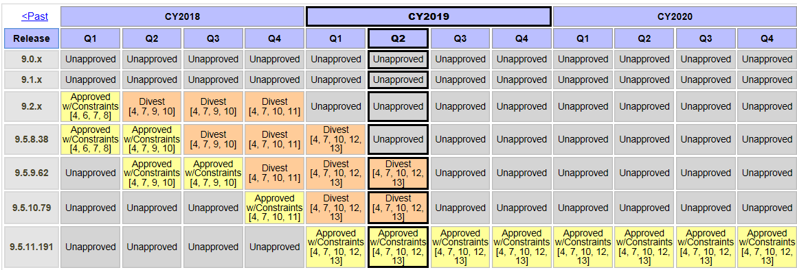

**EnCase Agent 7.10.4.2-3.el7.x86_64 (IO Gold-Image Sourced)** [**http://trm.oit.va.gov/ToolPage.aspx?tid=10758&tab=2**](http://trm.oit.va.gov/ToolPage.aspx?tid=10758&tab=2)

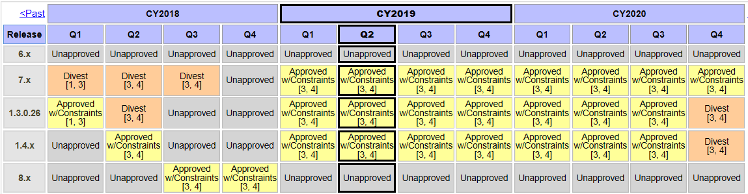

**McAfee Agent 5.0.5-658.x86_64 (IO Gold-Image Sourced)** [**http://trm.oit.va.gov/ToolPage.aspx?tid=6206&tab=2**](http://trm.oit.va.gov/ToolPage.aspx?tid=6206&tab=2)

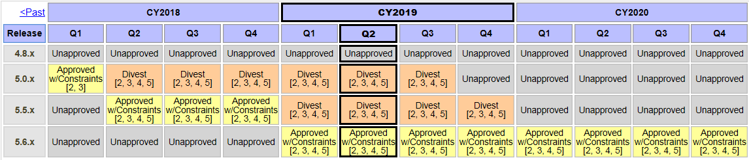

**Centrify Infrastructure Services 2018 (Satellite Repo Sourced)** [**http://trm.oit.va.gov/ToolPage.aspx?tid=6545&tab=2**](http://trm.oit.va.gov/ToolPage.aspx?tid=6545&tab=2)

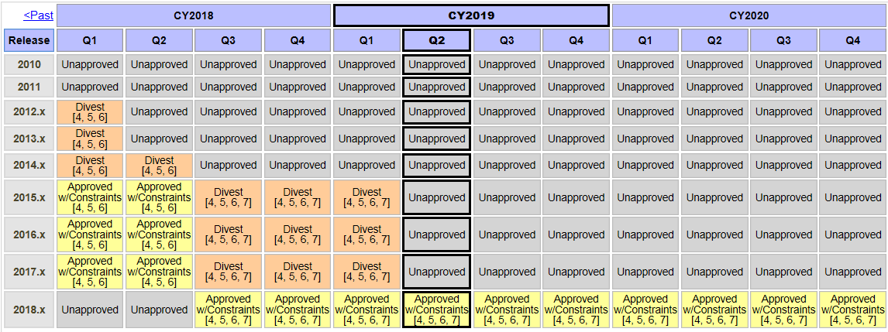

**Rational Team Concert (RTC) Eclipse Client 6.0.6** [**http://trm.oit.va.gov/ToolPage.aspx?tid=11281&tab=2**](http://trm.oit.va.gov/ToolPage.aspx?tid=11281&tab=2)

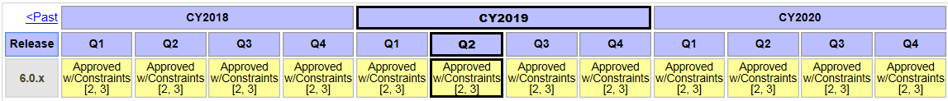

**Jenkins Continuous Integration Server 2.150.2** [**http://trm.oit.va.gov/ToolPage.aspx?tid=6397&tab=2**](http://trm.oit.va.gov/ToolPage.aspx?tid=6397&tab=2)

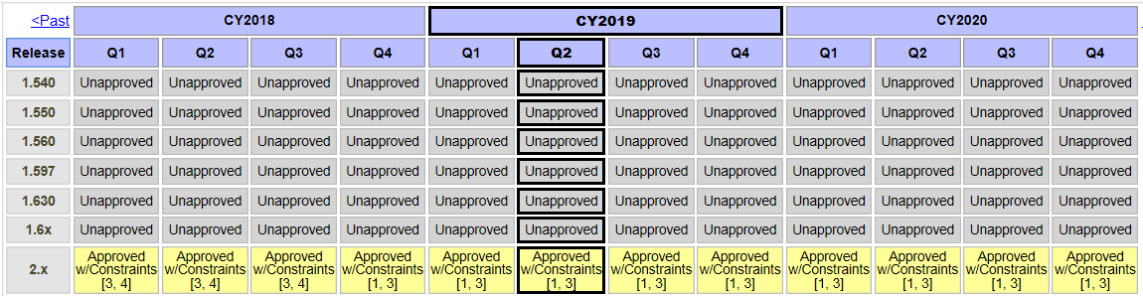

**Ansible 2.4.2.0** [**http://trm.oit.va.gov/ToolPage.aspx?tid=8196&tab=2**](http://trm.oit.va.gov/ToolPage.aspx?tid=8196&tab=2)

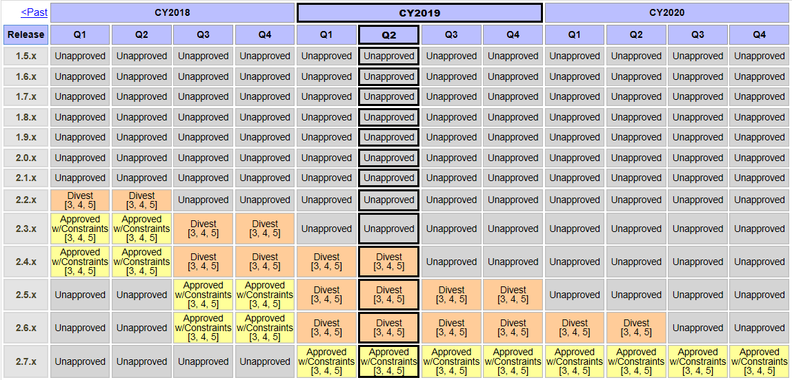

**Computer Associates (CA) Single Sign-On (SSO) 12.51 cr08** [**http://trm.oit.va.gov/ToolPage.aspx?tid=5834&tab=2**](http://trm.oit.va.gov/ToolPage.aspx?tid=5834&tab=2)

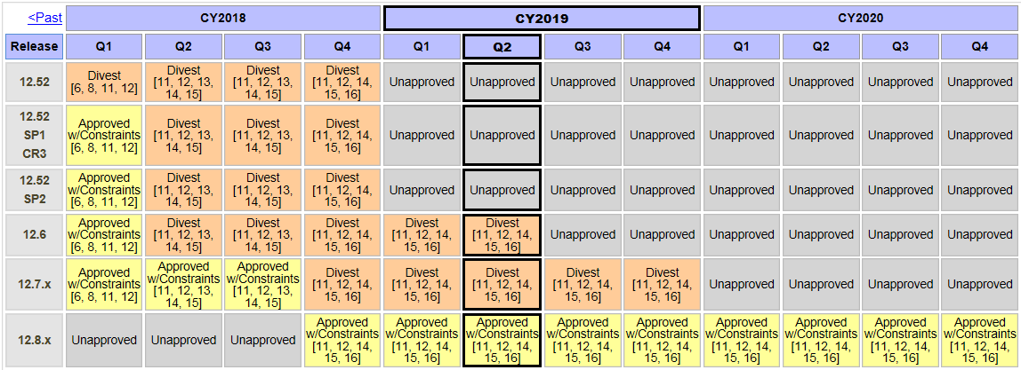

**Node Package Manager (NPM) 5.x** [**http://trm.oit.va.gov/ToolPage.aspx?tid=13022&tab=2**](http://trm.oit.va.gov/ToolPage.aspx?tid=13022&tab=2)

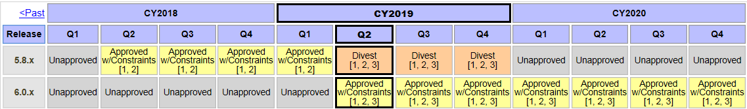

**Font Awesome 4.7.x** [**http://trm.oit.va.gov/ToolPage.aspx?tid=10342&tab=2**](http://trm.oit.va.gov/ToolPage.aspx?tid=10342&tab=2)

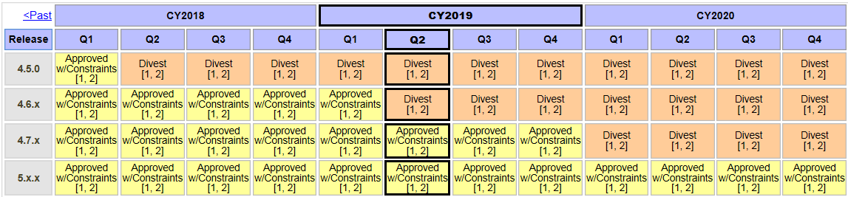

**Apache Hypertext Transfer Protocol (HTTP) Server 2.4.6-45** [**http://trm.oit.va.gov/ToolPage.aspx?tid=5009&tab=2**](http://trm.oit.va.gov/ToolPage.aspx?tid=5009&tab=2)

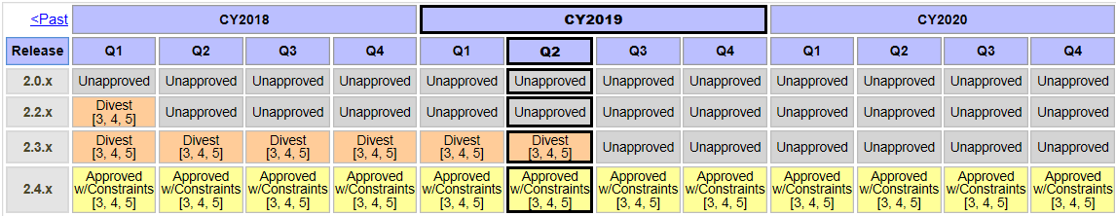

**Apache Tomcat 9.05** [**http://trm.oit.va.gov/ToolPage.aspx?tid=5451&tab=2**](http://trm.oit.va.gov/ToolPage.aspx?tid=5451&tab=2)

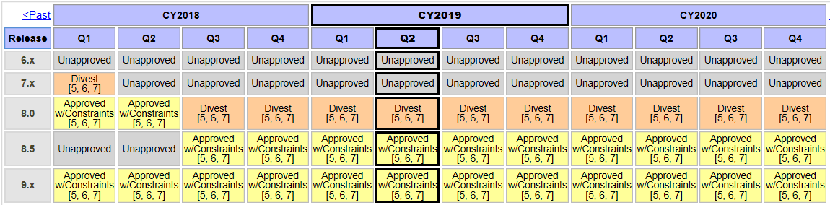

**U. S. Web Design Standards Framework 1.1.0** [**http://trm.oit.va.gov/ToolPage.aspx?tid=11196&tab=2**](http://trm.oit.va.gov/ToolPage.aspx?tid=11196&tab=2)

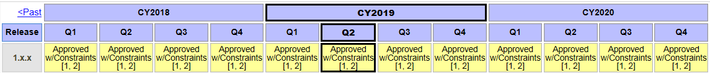

**Node.js 8.x** [**http://trm.oit.va.gov/ToolPage.aspx?tid=6716&tab=2**](http://trm.oit.va.gov/ToolPage.aspx?tid=6716&tab=2)

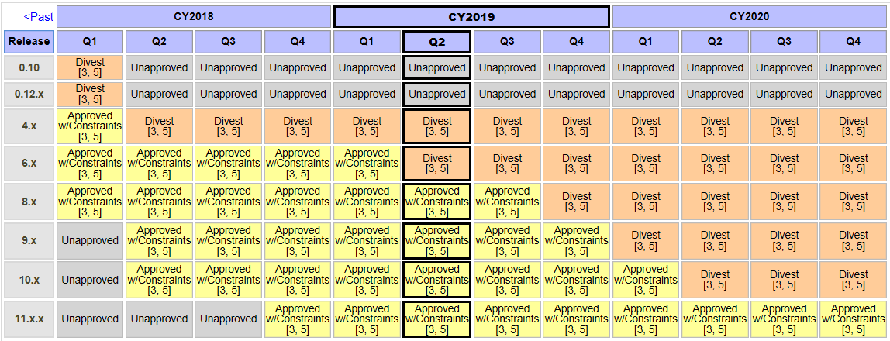

**Process Manager 2 (PM2) 2.4** [**http://trm.oit.va.gov/ToolPage.aspx?tid=10869&tab=2**](http://trm.oit.va.gov/ToolPage.aspx?tid=10869&tab=2)

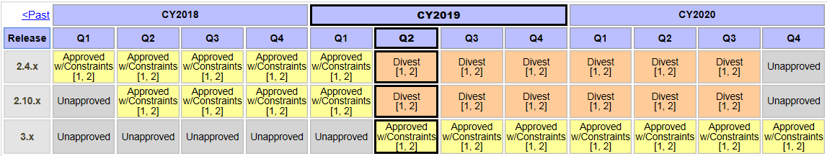

**PrimeNG 4.2** [**http://trm.oit.va.gov/ToolPage.aspx?tid=11566&tab=2**](http://trm.oit.va.gov/ToolPage.aspx?tid=11566&tab=2)

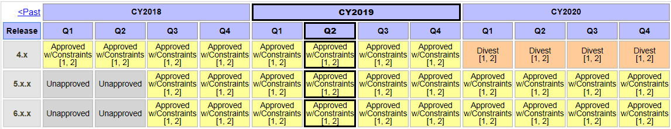

**Angular 4.0** [**http://trm.oit.va.gov/ToolPage.aspx?tid=13144&tab=2**](http://trm.oit.va.gov/ToolPage.aspx?tid=13144&tab=2)

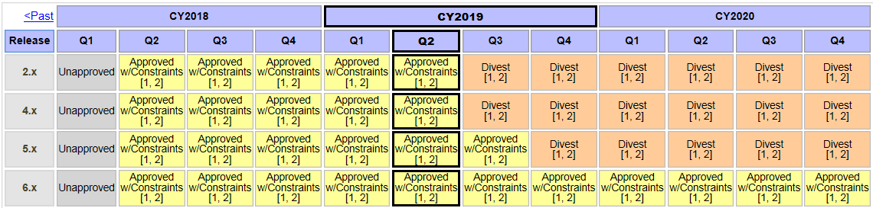

**RabbitMQ 3.7.7** [**http://trm.oit.va.gov/ToolPage.aspx?tid=7738&tab=2**](http://trm.oit.va.gov/ToolPage.aspx?tid=7738&tab=2)

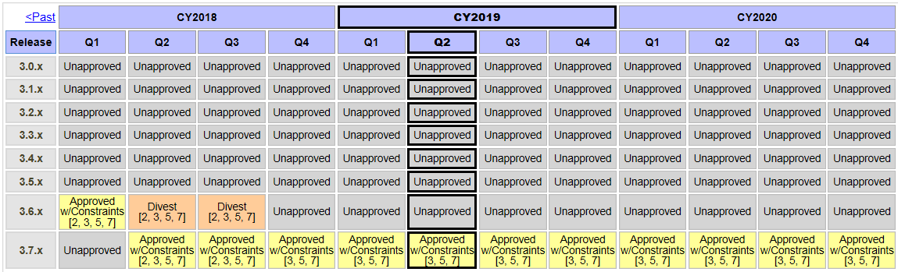

**Health Level 7 (HL7) Application Programming Interface (API) (HAPI) - Fast Healthcare Interoperable Resources (FHIR) 2.5** [**http://trm.oit.va.gov/ToolPage.aspx?tid=8870&tab=2**](http://trm.oit.va.gov/ToolPage.aspx?tid=8870&tab=2)

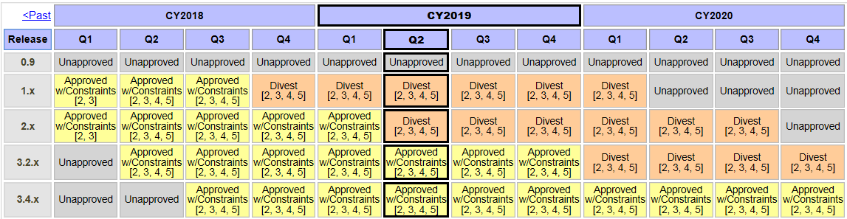

**Docker - Community Edition (CE) 17.09.1** [**http://trm.oit.va.gov/ToolPage.aspx?tid=10963&tab=2**](http://trm.oit.va.gov/ToolPage.aspx?tid=10963&tab=2)

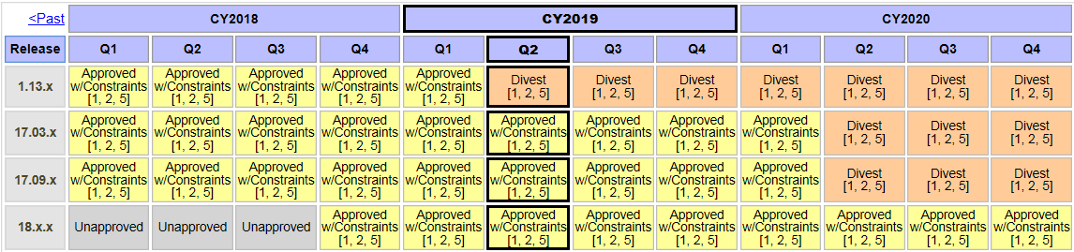

**Nginx 1.14.1** [**http://trm.oit.va.gov/ToolPage.aspx?tid=6605&tab=2**](http://trm.oit.va.gov/ToolPage.aspx?tid=6605&tab=2)

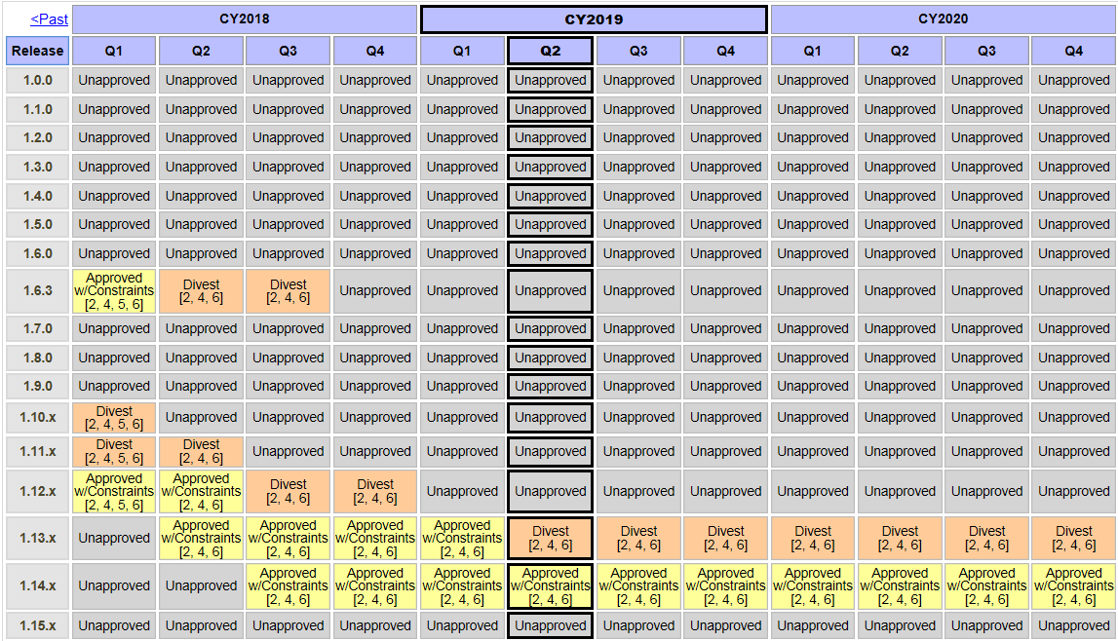

**Fortify Static Code Analyzer 18.20** [**http://trm.oit.va.gov/ToolPage.aspx?tid=6429&tab=2**](http://trm.oit.va.gov/ToolPage.aspx?tid=6429&tab=2)

